RESOLUTION NO.__________

RE: CERTIFICATE OF APPROPRIATENESS UNDER THE
PROVISIONS OF THE ACT OF THE PENNSYLVANIA
LEGISLATURE 1961, JUNE 13, P.L. 282 (53
SECTION 8004) AND BETHLEHEM ORDINANCE NO.
3952 AS AMENDED.

WHEREAS, it is proposed to install a sign at 226 E. Third Street.

NOW, THEREFORE, BE IT RESOLVED by the Council of the City of Bethlehem that a Certificate of Appropriateness is hereby granted for the work.

Sponsored by: (s)

(s)

ADOPTED BY COUNCIL THIS DAY OF

(s)
President of Council

ATTEST:

(s)
City Clerk

HISTORIC CONSERVATION COMMISSION

CASE # 585– It is proposed to install a sign at 226 E. Third Street
OWNER/APPLICANT: Kevin Luna/John Prokopovich

The Commission upon motion by Mr. Hudak seconded by Mr. Lousch adopted the proposal that City Council issue a Certificate of Appropriateness for the proposed work described herein:
- The proposal to install a sign at 226 E. Third Street was represented by John Prokopovich.

- The new sign will read “Steel Nutrition” with “Steel” in a rusty color lettering with black rivets and “nutrition” in a bright green

- Etched glass film may be placed on the front window, door and transom to provide privacy.

- The hours will also be on the door with 1½” of empty space between the sign and the sides of the door frame.

- A scale drawing of the sign and its colors must be submitted for final approval.

- The proposed motion was unanimously approved.

CU: cu
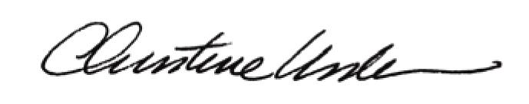

By:

Date of Meeting: March 21, 2016 Title: Historic Officer

